Chapter 2: Disentangling the drivers of pollinator-mediated interactions between creosote bush (*Larrea tridentata*) and desert dandelion (*Malacothrix glabrata*).

Like title – could also have a snap/joke/metaphor or link to the bigger idea? PMI is the idea or theory – but could use a more general eco-term that ie broader – facilitation, indirect interactions, collective attraction – attractant/decoy etc. think over.

Abstract

In arid ecosystems, the facilitative effects of shrubs can lead to concentrations of annual plants beneath the canopy. The indirect interactions that arise from the close spatial proximity of nurse-protégé relationships can have important implications for community structure and assembly. Creosote bush, *Larrea tridentata* is a dominant shrub of the Mojave Desert. Here, we test for the capacity of creosote bush to influence the pollination of its annual understory during its phenological shift into flowering. Pollinator visitation rates to the phytometer desert dandelion were significantly lower to? the understory of creosote bush, and when creosote bush entered into a full bloom, visitation rates declined significantly at both understory and nearby open microsites. The decrease in visitation was driven by behavioural responses of solitary bees and syrphid flies. In this system, we found that *L. tridentata* has a positive ecological effect on associated annual plants and the arthropod community, but this shrub further had negative indirect effects on pollination of a representative flowering annual plant. This study confirms the positive role of *L. tridentata* as a foundation plant but more importantly suggests that the net outcome of interactions can be negative or positive depending on the specific shrub function tested or the recipient taxa. – LOVE it – something like that? Love it.

Introduction

Foundation species positively influence the structure of the surrounding plant communities by creating locally stable conditions for other species (Ellison et al., 2005). In arid environments, foundation shrubs can act as keystone facilitators, directly benefiting associated understory annual plants via multiple mechanistic pathways across all life stages (Filazzola and Lortie, 2014). These include stress amelioration (McIntire and Fajardo, 2014), improved water and nutrient availability (Franco et al., 1994), and seed trapping (Flores and Jurado, 2003). Direct interactions between shrubs and annuals can be simultaneously facilitative and competitive (Bertness and Callaway, 1994; Callaway and Walker, 1997b; Holzapfel and Mahall, 1999), and it has been proposed that the relative importance of negative version position effects covaries with abiotic stress (Bertness and Callaway, 1994; Schafer et al., 2012; Tielbörger and Kadmon, 2000). These complex sets of interactions lead to patterns in species coexistence and structure plant communities (Brooker et al., 2008; Valiente‐Banuet and Verdú, 2007). The facilitative effects of desert shrubs can lead to concentrations of annual plants beneath the shrub canopy (Facelli and Temby, 2002). This close spatial proximity of shrubs and annuals undoubtedly gives rise to indirect interactions (Sotomayor and Lortie). Indirect interactions arise whenever a third species alters the interaction between two other species (Callaway and Pennings, 2000; Callaway and Walker, 1997b; Wootton, 1994). If the associated annual is a flowering plant, then there is the capacity for the plants to interact indirectly via pollinators.

Shrub-annual plant mechanistic pathways requiring co-blooming dominate the study of the underlying mechanisms of pollinator-mediated interactions. These are primarily extensions to optimal foraging theory (Pyke, 1984; Pyke et al., 1977) with flowers as the central resources for which pollinators forage. Thus plants can become more attractive by combining their floral displays to increase net floral patch size (Schemske, 1981) or to make the patch offering more diverse (Ghazoul, 2006). Flowering desert shrubs offer concentrations of floral resources for foraging pollinators, and this can facilitate co-blooming annuals. Magnet species are particularly attractive to pollinators increasing local pollinator abundances that benefit their less attractive neighbours (Laverty, 1992; Thomson, 1978) – we resent that ☺. Shrubs are salient features of desert scrub ecosystems due their large size and structural complexity relative to ephemeral plants and can also influence the pollination of associated plants via non-floral mechanistic pathways. Shrubs may facilitate their annual understory by improving conditions for pollinators by offering shelter or habitat. Alternatively, annuals growing under shrubs can be physically obscured from foraging pollinators or shaded thereby reducing visitation. For example, shading by the shrub *Lonicera* decreases pollinator visitation and pollen deposition to its understory annuals (McKinney and Goodell, 2010). Consequently, direct and indirect shrub effects on other plants are likely functions at the same time on pollination outcomes.? Something like that – simpler statement.

## KEEP in intro BUT you could consider moving to methods under study site. The Mojave Desert is a biodiversity hotspot supporting 659 species of bees (Saul-Gershenz et al., 2012) and 1680 species of vascular plants (Rundel and Gibson, 2005). Despite the celebrated biodiversity of Southwestern Deserts, pollinator-mediated interactions in this region are infrequently tested. Intraspecific density has been shown to benefit the pollination of desert mustard *Lesquerella fendleri* (Roll et al., 1997); however, interspecific studies have primarily focused on competition within cacti systems in the Sonoran Desert (Fleming et al., 2001). Plant-pollinator systems in southwest deserts are home to rare obligate mutualisms such as the Joshua tree *Yucca brevifolia* and Yucca moths (Pellmyr, 2003), and the senita? cactus *Pachycereus schottii* and senita moths (Fleming and Holland, 1998) and are often considered highly specialized. The degree of specialization of desert ecosystems is a subject of ongoing debate. Desert organisms are hypothesized to adapt to high environmental variability by generalizing resource use (Chesson et al., 2004), and this has garnered recent empirical support in pollination networks (Chacoff et al., 2012). Overall, few one-to-one relationships have been found with solitary bees (Simpson and Neff, 1987), and bees still visit even Senita cactus (Holland and Fleming, 2002). Despite the high number of specialist bees? present in the Mojave, most plant species nonetheless interact through (shared?) pollinators. Or through pollinators and their interactions?

MOVE TO METHODS Creosote bush, *Larrea tridentata* (Zygophyllaceae), has been a dominant flowering shrub of the southwestern United States for 25 000 years (Betancourt et al., 1990). It is able to maintain photosynthesis even under high temperatures and low water potentials (Barbour et al., 2007). This shrub species also primarily reproduces clonally leading to individuals that are exceptionally long lived. Clones that are over 1000 years old have been documented (Vasek, 1980). The full pollinator guild contains 22 specialist pollinators and more than 80 generalists (Minckley et al., 1999). The associated pollinator guilds are highly variable over space, and most shrubs will only interact with 20% of their full guild (Cane et al., 2005). *L. tridentata* is one of the most reliable flowering plants in the Mojave because it has one of the lowest rainfall thresholds (12 mm) for blooming (Bowers and Dimmitt, 1994). It produces copious nectar and pollen rich flowers (Simpson et al., 1977) and provides critical resources to pollinators in drought years. *L. tridentata* functions as a benefactor species for other desert perennials such as *Opuntia leptocaulis*, (Yeaton, 1978), *Peniocereus striatus* (Suzán et al., 1994), and facilitates native annuals (Schafer et al., 2012).

A plant’s life stage can alter the balance of facilitative and competitive interactions ([Bruno et al., 2003](#_ENREF_10" \o "Bruno, 2003 #25); [Callaway and Walker, 1997a](#_ENREF_12" \o "Callaway, 1997 #132); [Pugnaire et al., 1996](#_ENREF_63" \o "Pugnaire, 1996 #19); [Rousset and Lepart, 2000](#_ENREF_69" \o "Rousset, 2000 #246); [Valiente-Banuet et al., 1991](#_ENREF_85" \o "Valiente-Banuet, 1991 #143)). The majority of research on plant-plant interactions focusses on a single life stage ([Goldberg et al., 2001](#_ENREF_32" \o "Goldberg, 2001 #247); [Tielbörger and Kadmon, 2000](#_ENREF_83" \o "Tielbörger, 2000 #20)) which is inadequate for making conclusions about fitness levels within populations ([McPeek and Peckarsky, 1998](#_ENREF_50" \o "McPeek, 1998 #248)). For example, within some nurse plant systems young plants are facilitated during establishment, but later compete with their nurses for resources ([Yeaton, 1978](#_ENREF_93" \o "Yeaton, 1978 #15)). For plants, the shift from vegetative growth to reproductive growth is a major event. Foundation plants have benefits that can scale to trophic levels beyond their surrounding plant community ([Reid and Lortie, 2012](#_ENREF_66" \o "Reid, 2012 #58); [Ruttan et al., 2016](#_ENREF_72" \o "Ruttan, 2016 #249)), however if these benefits change with reproductive shifts is not known. CUT or reduce to 1-2 sentences and work into the net interaction paragraph as another dimension to best estimating net outcomes in interaction sets.

The purpose here was to examine both the direct and indirect effects of *Larrea tridentata* on the pollination of the commonly co-occurring annual *Malacothrix glabrata*. *L. tridentata* and *M. glabrata* co-flower at beginning and ends of their bloom period (Jennings, 2001), making it an interesting and relevant system to model changes in interactions within a season. The main hypothesis is that *L. tridentata* interferes with the pollination of *M. glabrata* because its large size obscures them from foraging pollinators. We predict that this interaction shifts to facilitation when co-blooming because *L. tridentata* acts as a magnet species due to its high abundance of floral resources. Understanding interactions for pollination at a community level is critical for understanding potential impacts of any decline in pollinator populations. If shrubs facilitate their understory annuals, they may be able to buffer their associates from a pollinator decline. However if they outcompete them, their associates may be particularly vulnerable. Species interactions are important for structuring desert communities despite intense environmental pressure (Chesson et al., 2004). By separating mechanistic interaction pathways (i.e. co-blooming, not co-blooming), we may gain insight into adaptations to both environmental and species interactions.

**Methods**

Study site

The study area has an extent of 0.07 km2, and is located in the mouth of Sunset Cove on the property of the Granites Mountains Desert Research Station, within the Mojave National Preserve in California (34°46'26.5"N 115°39'31.3"W). The cove is created by tall rock formations on three sides, gently sloping and widening to the south. The diverse shrub and cactus community includes *Larrea tridentata*, *Acamptopappus sphaerocephalus*, *Ambrosia salsola, Eriogonum fasciculatum, Cylindropuntia acanthacarpa, Cylindropuntia echinocarpa* and *Thamnosa montana*. The most common flowering annuals present during the study period were *Cryptantha sp, Phacelia fremontii, Eriophyllum wallacei, Gilia sp., Phacelia tanacetifolia, Malacothrix glabrata* and *Chaenactis fremontii*.

Phytometer species

Phytometers are individual plants used in a controlled way as environmental indicators (Clements and Goldsmith, 1924). We used the desert dandelion *Malacothrix glabrata* (*Asteraceae*) as a phytometer to measure pollination services. *M. glabrata* is an abundant, native annual wildflower that commonly co-occurs with *L. tridentata*. The flowerheads are dense with yellow corollas and grow up to 40 cm tall (Morhardt and Morhardt, 2004). *M. glabrata* is insect-pollinated, including bees in the genus *Nomadopsis* (Rutowski and Alcock, 1980) and *Anthidium* (Wainwright, 1978) as well as short-winged flower beetles (Cline and Audisio, 2010). Several of the 24 species of *Malacothrix* are self-compatible (Davis and Philbrick, 1986), however the reproductive biology of *M. glabrata* has not been studied in detail.

Study design

60 medium-sized (mean width: 336 cm, mean height: 209 cm) *L. tridentata* shrubs possessing developed floral buds and minimal perennial understory were chosen across the study site. Microsites were located in a paired fashion; one inside the dripline of the focal plant (“shrub”) and one a minimum of 1.5 m away in an open area (“open”), both on the south side of the shrub to minimize shading. Microsites were paired to minimize variation due to environmental heterogeneity. To separate floral and non-floral interaction pathways, interactions were tested prior to focal shrubs blooming and repeated using the same shrubs after they had entered into full bloom. Shrubs with fewer than five open blooms were considered non-blooming (“pre-blooming”). The mean number of blooms of the ‘blooming’ treatment was 300.2 ± 176.72SD (min: 102, max: 1080). In two cases, a focal shrub did not bloom within the study period and was replaced by a different blooming shrub. These two cases were excluded from later RII calculations. The repeated measures study design was chosen to measure relative changes in interactions with natural shrub phenology and to reduce between shrub variability.

Visitation to *Malacothrix glabrata*

Each morning of each study day, *M. glabrata* were gathered from nearby (< 3 km) populations where they seasonally coexist with *L. tridentata.* These were transplanted into 15 cm diameter black pots and one pot was placed per microsite for a total of six shrub/open pairs per day. Conspecific floral density influences pollinator visitation (Bosch and Waser, 2001). Therefore, transplants of similar size and habit were paired, and the flowerheads of *M. glabrata* were trimmed to equal numbers between paired microsites, but left to vary between replicates. The mean number of flowers per pot was 10 (min 6, max 20). Polaroid Cube+ HD video cameras (1080p) were used to record pollinator activity to each potted *M. glabrata*. Recording periods were timed to coincide with peak pollinator activity (between 11:30 am and 3:30 pm, mean length: 1:19 hr:min). The use of video technology allows for higher temporal resolution, and replication beyond what is possible using traditional insitu observations. Ten days of pre-blooming trials (60 shrub/open pairs) were conducted between April 10 and April 20 and ten days of blooming trials (60 shrub/open pairs) between April 21 and May 2.

To test for any influence of naturally co-occurring annuals and blooming shrubs, heterospecific annual floral density was measured within a 0.25 m2 quadrat in each microsite and the number of heterospecific shrubs in bloom were counted within a 2 m radius of each microsite. The number of open blooms of each *L. tridentata* were counted at the same time.

Video footage was reviewed in lab. A flower visit was defined as when an insect visitor flew on and touched the open side of the flower. A foraging bout was defined as a single plant visit, beginning when a flying visitor touched a flower and ending when the visitor left the final flower. Visit duration included inter-flower travel time and multiple flowers could be visited during one foraging bout. Total flowers are the total number of flowers visited per replicate. Proportion of flowers visited is the number of unique flowers visited per foraging bout divided by the number of flowers in the field of vision. Floral visitors were identified to recognizable taxonomic units (RTU): honeybees, solitary bees, Lepidoptera, syrphid flies, bombyliid flies and other, which was comprised primarily of small beetles and muscoid flies. Five videos were omitted due to disturbance or battery failure.

Arthropod and plant community sampling

Foundation species have positive effects that scale to trophic levels beyond plants (Reid and Lortie, 2012; Ruttan et al., 2016). The arthropod communities were sampled to provide an estimate of pollinator availability for each microsite and to assess if *L. tridentata* acts as a foundation species within this system. Yellow, white and blue coloured, six-inch diameter plastic bowls filled with water with a few drops of Dawn original dish detergent added were used as pan traps. Each study day pan traps were set out by 10 am and collected by 5:30 pm. Arrays of three pan traps were deployed in a triangular shape at each microsite, slightly embedded in the ground to prevent disturbance. Total percent vegetation cover (a proxy for annual biomass) and annual species richness were recorded within a 0.25 m2 quadrat when the traps were laid out. Arthropod sampling was conducted within two days of the video test, but never on the same day to avoid influencing visitation. Nine days (54 shrub/open pairs) of sampling were completed before blooming, and 10 days (60 shrub/open pairs) during full bloom.

Bees and syrphid flies were identified to species or genus (Ascher and Pickering, 2015; Michener, 2000; Michener et al., 1994; Miranda et al., 2013). The majority of remaining individuals were identified to a minimum of family (Grissell and Schauff, 1990; Marshall, 2012; Teskey et al., 1981; Triplehorn and Johnson, 2005) Thysanoptera, Orthoptera and Arachnida which were left to order. Recognizable taxonomic unit (RTU) is a suitable approximation of traditional species richness (Oliver and Beattie, 1993). Using RTU limits resolution compared with species-level identification, however many desert insect species have not been described and furthermore useful keys are often lacking. This method of categorizing diversity was a trade-off between maximizing resolution and speed given the high diversity of desert species. Related groups may be identified to different levels. E.g. wasps in the genus *Miscophus* and subfamily *Pemphredoninae* are both within the family *Crabronidae*. No individuals were double counted, and these groups were considered distinct, exclusive RTUs for diversity analyses. Nymphs were included in abundance analyses provided they could be identified at least order. Hemipteran nymphs that could not be identified to family were lumped together for diversity analyses, otherwise all nymphs were assigned to family. Mites (Acari) and springtails (Collembola) were excluded from all analyses due to biases in collection methods. A full list of the 121 RTU are provided in the Appendix and the associated dataset has been (will be) published openly to KNB. All specimens are located within the Lortie Lab at York University.

Pollinator visitation to *Larrea tridentata*

Pan traps are insufficient to quantify the pollinator guild of L. tridentata (Cane et al, 2000). To determine which pollinators visited *L. tridentata* during the study period, visitation to *L. tridentata* was observed in 15-minute time periods. Four individuals were observed per day, 10 days pre-blooming (10 hours) and 6 individuals per day for 10 days when blooming (14.5 hours). The same focal shrubs were observed, but on different days than pan trap sampling and video trials. Due to the large size of the shrubs, it was not possible to accurately track flower visits per foraging bout, therefore only the frequency of foraging bouts was recorded. The identity and behaviour of the visitors were recorded and visitors were collected when possible to aid identification.

Microclimates

To determine if *L. tridentata* creates locally stable microclimates, 16 HOBO pendant data loggers were used to record micro-environmental conditions. Ground level temperature and light availability were recorded every 30 minutes between March 19th and May 14th, 2017 at eight microsite pairs. Daytime (9am to 9pm) and nighttime (9pm to 9am) averages and daily temperature variance were calculated.

Pollen deposition

To quantify how pollen deposition is influenced by proximity to *L. tridentata*, I collected stigma from *M. glabrata* at a nearby site (3 km) with a naturally occurring, co-blooming populations of *M. glabrata* and *L. tridentata* between April 31st and May 2nd. It was necessary to use a different site because *M. glabrata* populations at the main site were too small. I collected three stigma from each of three flowers per *M. glabrata* (nine stigma per plant) growing under the dripline and in nearby open areas. A total of 298 stigma were collected from 13 shrub/open pairs. The small sample size is due to a heatwave followed by a wind storm that triggered all *M. glabrata* to go to seed. Distance to the nearest *L. tridentata* and three nearest *M. glabrata* neighbours were measured, and the number of *M. glabrata* flowers per plant were counted. The stigmas were stored individually in micro centrifuge tubes filled with denatured alcohol. The tubes were spun down in a centrifuge at 4200 rpm for 4.5 minutes and the pellet pipetted onto the slide. This along with the stigma were mounted in fuchsin jelly (Kearns and Inouye, 1993). At 100 x magnification, 10 longitudinal transects (18 mm long) of pollen were counted per slide. Heterospecific pollen grains were imaged using a Canon 60D SLR with 60mm macro lens into microscope afocally.

Statistical Analysis

To test for evidence that *L. tridentata* mediates pollinator visitation to *M. glabrata*, I fit generalized linear mixed-models (GLMM, lme4) using negative binomial error distributions with a loglink function to account for overdispersion within the data. I used the number of foraging bouts and the total number of flowers visited as response variables. Video length was log-transformed to match the loglink function and used as an offset to maintain the count structure of the data. To test for the influence of conspecific floral density, the number of *M. glabrata* blooms were included in as a predictor (flowers.pot). In the past, some have chosen to standardize visitation to visits/hour/flower, this makes the assumption that pollinators respond linearly to conspecific floral density and that the slope of the relationship does not change with any treatment. The method used allows for the original data distribution to be maintained (Reitan and Nielson, 2006), and for pollinator response to conspecific density to be tested rigorously. The rep ID (focal shrub number + microsite) was used as a random effect to account for the repeated measures study design in all models. Interactive, additive and intercept only models were compared by AIC and likelihood ratio tests with χ2 approximations (Appendix). To test for the influence of heterospecific blooming annuals and shrubs, I used negative binomial GLMM (glmmTMB) and added each covariate to the additive model (microsite + blooming + flowers.pot).

To explore which visitors were driving observed visitation patterns, I fit quasipoisson GLMM (glmmPQL, MASS) and used least-squares post hoc tests (lsmeans) on any significant interactions. To determine if *L. tridentata* influences foraging behaviour, I fit gamma GLMM models (glmer, lme4) with visit duration and proportion of flowers visited per foraging bout as response variables. As a post-hoc exploration, I subsetted responses of solitary bees and ‘other’ RTUs to fit linear mixed models for both RTU using log-transformed visit duration as the response variable. Least-squares post hoc tests (lsmeans) were used on any significant interactions.

Positive influences on other communities

To quantify how shrubs influence arthropod and plant communities, I fit negative binomial GLMM (lme4, glmer.nb), and arthropod abundance, percent annual cover, annual species richness and annual bloom density as response variables. Beetles from the family Melyridae made up 1217 of the 3384 total arthropods captured, therefore abundance models were fit with Melyridae excluded, included and individually to avoid bias. Poisson GLMM (lme4) were used to determine differences in arthropod species richness and bee abundance between the treatments. Rep ID was included as a random effect in all models, and least-squares post hoc tests were used on significant interactions (lsmeans). To test if *L. tridentata* individuals with more flowers are more attractive to pollinators, I used a quasipoisson GLM (glm) with visitation rates as the response and flower number as predictors.

Pollen Deposition

I fit quasipoisson models (MASS, glmmPQL) with conspecific and heterospecific pollen deposition as response variables. I used the distance to *L. tridentata*, distance to the nearest conspecific neighbour and the number of *M. glabrata* flowers as predictors. The sample ID nested in the flower ID nested in the plant was used as a random effect.

Ecological effects

To compare the ecological effect of shrubs and blooming on five community response metrics (floral visitation of *M. glabrata*, arthropod abundance, arthropod species richness, percent annual cover and annual species richness), and to estimate the biological importance of statistically significant differences the effect size estimate RII was calculated (Armas et al., 2004). The equation: $RII= \frac{treatment-control}{treatment+control}$ was used. Treatments were shrub microsite or blooming, while the controls were open microsite or pre-blooming. Microsites were matched when calculating the metric and non-matching sites were excluded from calculations. This metric is symmetric around 0, ranges from −1 to +1, and negative values denote relativecompetition whilst positives denote facilitation. To determine if the effect was significantly different from 0, 95% confidence intervals around mean values were bootstrapped (boot, R), stratified by the focal shrub ID to account for the repeated measures study design.

Climate amelioration

To test for the capacity of *L. tridentata* to create stable microclimates, I used GLMM (glmer, lme4) with Gamma error distributions with mean daytime temperature, mean nighttime temperatures and daily temperature variance as response variables. I used the shrub ID + microsite as a random effect to control for the repeated measures.

**Results**

Pollinator visitation to phytometer

A total of 697 flying insects made 925 potentially pollinating flower visits (hereafter “pollinators”) to *M. glabrata* in 303 hours of video recording. No pollinators were observed in 61 of the 235 video observation periods. Foraging bout frequency and total floral visitation by pollinators to *M. glabrata* were significantly lower at the shrub microsite relative to open areas (Table 1), and were reduced at both microsites when *L. tridentata* entered full bloom. There was a positive effect of *M. glabrata* conspecific density on both the frequency of foraging bouts and floral visitation.

There was no significant influence of heterospecific shrub blooming density on foraging bout frequency or total flowers visited. There was a significant, positive effect of heterospecific annual floral density on foraging bouts, but not flowers visited (Table 2). Floral visitation rates (flowers/hr) were significantly correlated between paired shrub/open microsites (Pearson’s = 0.262, t = 2.8708, df = 112, p-value = 0.004898).

There were RTU specific changes in the number of foraging bouts and flowers visited with blooming (Table 3). The frequency of flower visits by syrphids and solitary bees declined significantly with blooming (Table 4). There was no significant difference between RTU visiting the microsites (Figure 1, Table C1), nor were there significant interactions between RTU, microsite and blooming (Table C1) on the total flowers visited.

There was also a negative effect of *L. tridentata* blooming on *M. glabrata* visit duration, but no microsite effect (Table 5). This was driven by visitors in the ‘other’ category (Figure 2, Est: -1.0703, χ2: 12.274, t: -3.503, p = 0.000605). There was no difference in solitary bee visit duration between blooming treatments (Est: -0.9341, χ2: 1.9017, t: -1.379, p = 0.208).

The proportion of flowers visited per visit decreased significantly with blooming at the shrub microsite only (Table 5), but there were no significant interactions between RTU and blooming or RTU and microsite (Appendix).

Pollen Deposition

A total of 16209 grains of conspecific pollen and 1719 of heterospecific grains were counted. At the nearby site, there was no significant influence of proximity to *L. tridentata* or the number of conspecific flowers (Figure 3) on conspecific pollen deposition, however there was a marginally significant effect of distance to nearest conspecific neighbour (Table 6). Heterospecific pollen deposition increased significantly with distance from *L. tridentata*. Conspecific and heterospecific pollen deposition were significantly correlated (Pearson’s = 0.15, t = 2.397, df = 229, p = 0.01).

Visitation to larrea

Pollinator visitation to *L. tridentata* increased with floral abundance (GLM: Est: 0.0013408, χ2: 4.6383, p = 0.02283). Floral abundance and shrub height (Pearson’s = 0.335, t = 2.6659, df = 56, p = 0.01002) were correlated. *L. tridentata* received 197 floral visit over 15 hours of observations. Of 169 visits made by bees, *Apis mellifera* was the most frequent visitor (32%), *Centris* sp. (21%), *Hesperapis larrae* (18%) and *Megandrena enceliae* (7%) and other solitary bees (23%) including *Hoplitis* and *Megachile*.

Positive influences on other communities

3987 arthropods spanning 121 taxonomic groups (Appendix) were caught in 19 days of pan trapping. There was a positive effect of shrub microsite on both arthropod abundance (Melyridae excluded) and arthropod species richness, and a negative effect of blooming (Table 7, 8). Insect abundance (Melyridae excluded) was significantly correlated between paired shrub/open microsites (Pearson’s = 0.46, p < 0.001). Melyridae abundance was significantly lower at the shrub microsites, and decreased with blooming at the open microsite only (Table 7). There was no significant difference in bee abundance caught in pan traps between any of the treatments (Table 8).

Percent cover of ground vegetation was significantly greater in shrub microsites (Table 9) and it decreased with blooming in the open microsite only. There was a significant decrease in annual floral density with blooming, but no difference between the microsites. There was no significant difference in annual species richness between any of the treatments.

Ecological effects

Shrubs had a competitive effect on floral visitation of *M. glabrata,* a facilitative effect on arthropod abundance, arthropod species richness, annual percent cover and a neutral effect on annual richness. Blooming had a negative effect on all metrics (Figure 5).

Climate amelioration

Mean daytime temperatures were significantly lower (Figure 6, GLMM: Est: -0.064678, χ2:85.51, p <0.0001), and mean nighttime temperatures were significantly higher under the shrub canopy (GLMM: Est: 0.059203, χ2: 50.121, p <0.0001). Overall temperature variation was significantly lower in the shrub microsites (GLMM: Est: -0.27977, χ2: 523.38, p <0.0001).

**Discussion**

*Larrea tridentata* engaged in simultaneous positive and negative interactions with the surrounding plant and arthropod communities. There was partial support for the main hypothesis. *L. tridentata* interfered with the pollination of *M. glabrata* but this was not alleviated when *L. tridentata* entered full bloom. *L. tridentata* competed with rather than facilitated *M. glabrata* by blooming. There was a facilitative effect of annual heterospecific blooms on the number of foraging bouts made, but not flower visits. The observed negative effect of the shrub microsite was likely due to obscuring because there was no species specific response. The term magnet species refers to a highly attractive plant species (Laverty, 1992; Molina-Montenegro et al., 2008). However, the traits that make a plant attractive to pollinators, such as a large floral display (Bosch and Waser, 2001), height (Donnelly et al., 1998), flower size (Conner and Rush, 1996) or rich rewards (Robertson et al., 1999) also make it likely to be a good competitor. Thus, the sign of this interaction is likely context-dependent. In this study, the context leading to competition was the identity, phenology and foraging behaviours of the associated pollinator communities.

Pollinator-mediated interactions

The decrease in visitation upon co-blooming was driven by syrphid flies and solitary bees. *Eupeodes volucris* (Diptera: Syrphidae), the bird hoverfly, was the most frequent floral visitor to *M. glabrata* and is known to visit *L. tridentata* (Hurd Jr and Linsley, 1975). Only one syrphid floral visit to *L. tridentata* was recorded. This change in visitation may be due seasonal changes in Syrphid abundance, particularly if it is tied to the phenology of annuals. *E. volucris* is multivoltine (Vockeroth, 1992) and the average maturation time is 21 days in lab (Jones, 1922) however the phenology of *E. volucris* in desert systems has not been studied. In the only study measuring seasonal hoverfly abundances in USA, *Eupeodes* abundances peaked in late spring but individuals were found throughout the season (Terry and Nelson, 2017). Larval *E. volucris* are aphid predators and members of the genus *Eupeodes* requires specific larval resources (Henderson, 1982). In an agricultural study on aphid-eating hoverflies, including *E. volucris,* abundances corresponded to aphid densities (Noma and Brewer, 2008). In a Rocky Mountain alpine community, early snowmelt triggered flowering, but not syrphid fly emergence suggesting their phenology is not closely tied to weather (Iler et al., 2013). Overall their phenology appears to be tied to prey availability rather than floral resource availability. A novel area of research would be to understand the likely complex relationships between pollinators that have predatory larva and the plants that host their prey.

Alternatively, bees may have competitively excluded Syrphids from the immediate area. Competition between Syrphids and other pollinators is fairly unstudied (Inouye et al., 2015). Bumblebees outcompete *Toxomerus* (Morse, 1981) leading to the temporal partitioning of pollinators. Temporal partitioning is unlikely to be the case in this study as there were few Syrphids caught in pan traps relative to pre-blooming. *Centris* sp. bees, which were frequent visitors to Larrea flowers are territorial, and will hover near shrubs chasing off other bees (Alcock et al., 1977). Honeybees have been shown to reduce visitation by native, solitary bees but the effect is not consistent (Shavit et al., 2009), and they can compete via multiple mechanisms including resources depletion and competitive displacement (Cane and Tepedino, 2017). If the pollinators of one plant displace the pollinators of another plant, this would be a novel mechanism of pollinator competition in arid environments.

Pollinators responded positively to the floral density of *L. tridentata* i.e. concentrations of floral resources, however this did not benefit *M. glabrata*. This can be explained in part by the identity and behaviour of the visitors to *L. tridentata*. *Megandrena encelia* (Hymenoptera: Andrenidae) and *Hesperapis larrae* (Hymenoptera: Melittidae) are both locally oligolectic, generally visiting *L. tridentata* exclusively as long it is present (Hurd Jr and Linsley, 1975). The most frequent floral visitors to *L. tridentata* were feral honeybees, *Apis mellifera*. Honeybees preferentially forage on particularly abundant flowers, exhibiting floral constancy. This is a common feature of social bees where individuals facultatively specialize on different flower species at different times (Waser, 1986). Furthermore, because honeybees communicate the locations of food sources to the colony, arriving bees may be looking for *L. tridentata*, rather than openly foraging. The significant decline in solitary bee visitation to *M. glabrata* when co-blooming was not driven by local changes in bee abundances suggests that it was a behavioural response. **Need to add a test for community composition.** Switching to a plant species offering superior resources during a spring bloom has been observed in the alpine (Mosquin, 1971). Manipulation experiments have found competition between sequential bloomers (Campbell and Motten, 1985). During co-blooming, pollinators spent less time foraging on *M. glabrata*, and visited fewer flowers per visit, which is consistent with pollinator parasitism by *L. tridentata*. However, because they were not observed at the same time it is not possible to conclude that this was caused by pollinators leaving.

There was a facilitative effect of heterospecific annual floral density on the number of foraging bouts made but no difference in annual floral density between microsites. There was a decrease with L. tridentata blooming, potentially signaling a shift from annual dominance to shrub dominance. **2 sentences or so expanding on this. Maybe shift this into community sections**

Overall the negative ecological effect of blooming was greater than the microsite effect. Differences in visitation do not necessarily lead to differences in fitness (King et al., 2013). Syrphid flies and solitary bees are well known as effective pollinators, so the reduction in their visits likely led to a reduction in pollen deposition, and subsequently fitness. At the nearby site, there was no change in stigma conspecific pollen loads with distance to *L. tridentata*, however the sample size was too low to conclude there was no effect. Heterospecific pollen deposition increased with distance to *L. tridentata,* suggesting that *L. tridentata* influences interactions between *M. glabrata* and other plants. The ability of plants to do this is a very interesting and underexplored area. After blooming, microsite differences were very small. The coinciding decrease in pollinator visitation to open microsites suggests that *L. tridentata*’s influence extends beyond its canopy. Further experiments examining the zone of influence and how it changes size with pollinator identity would help make better predictions as well as aid future experimental design.

Interactions with surrounding communities

In this system, *L. tridentata* is a foundation plant with positive effects that scaled to annual and arthropod communities. It buffered annuals through the study period by ameliorating and stabilizing understory microclimates which is a frequent mechanism within nurse plant systems (Filazzola and Lortie, 2014). Under climate warming scenarios, may continue to buffer.

Our results that L. tridentata supports arthropod species richness supports the findings of other authors that showed that arthropod communities show family specific associations with *L. tridentata* (Hurd and Linsely, 1975, Ruttan, 2016).

There were decreases in arthropod abundance and richness when L. tridentata entered into bloom. Scaling up of interactions through multiple trophic levels highlights the importance of positive interactions in deserts but the potential shifts when *L. tridentata* entered into a reproductive state suggest that these interactions are dynamic and complex, and change throughout the year. Melyidae beetles actually increased in abundance with blooming. Pan traps are not the best for sampling arthropods. I observed ~400 uses of L. tridentata, which included insect walking on the understory and hovering over flowers. Uses doubled compared to before blooming. It would be complicated to try to say what is happening here as arthropods are so diverse in lifecycles. What is clear though, is that L. tridentata supports arthropods in ways beyond providing copious floral resources. So it is important to pollinators, but also arthropods in general. L. tridentata stabilized the climate under the shrub. It has an evergreen canopy (cite), so this benefit is throughout the year. Biotic interactions are important to desert ecosystem functioning. The loss of L. tridentata would cascade. In Coachella valley, more than 60 species of insect are herbivores of L. tridentata. Ontogenetic shifts.

I think I need to do an RDA so I can talk about the actual shifts a bit better? Maybe.

Conclusions

My findings suggest that even though facilitation or neutral interactions between plants for pollinators may be measured during co-blooming, competition may be more biologically relevant overall. Therefore, experimental design is key to separating out net interactions. Diverging phenologies are hypothesized to result from competition avoidance (Waser and Real). These plants species overlap at the beginning and ends of their phenologies, potentially to avoid the observed competition. The positive effect on annual cover was greater than the negative effect on pollinator visitation. L. tridentata is an important species that supports plant, pollinator and arthropod communities.

Literature Cited

Alcock, J., Jones, C.E., Buchmann, S.L., 1977. Male mating strategies in the bee Centris pallida Fox (Anthophoridae: Hymenoptera). The American Naturalist 111, 145-155.

Armas, C., Ordiales, R., Pugnaire, F.I., 2004. Measuring plant interactions: a new comparative index. Ecology 85, 2682-2686.

Ascher, J., Pickering, J., 2015. Discover Life bee species guide and world checklist (Hymenoptera: Apoidea: Anthophila).

Barbour, M., Keeler-Wolf, T., Schoenherr, A.A., 2007. Terrestrial vegetation of California. Univ of California Press.

Bertness, M.D., Callaway, R., 1994. Positive interactions in communities. Trends in Ecology & Evolution 9, 191-193.

Betancourt, J.L., Van Devender, T.R., Martin, P.S., 1990. Packrat middens: the last 40,000 years of biotic change. University of Arizona Press.

Bosch, M., Waser, N.M., 2001. Experimental manipulation of plant density and its effect on pollination and reproduction of two confamilial montane herbs. Oecologia 126, 76-83.

Bowers, J.E., Dimmitt, M.A., 1994. Flowering phenology of six woody plants in the northern Sonoran Desert. Bulletin of the Torrey Botanical Club, 215-229.

Brooker, R.W., Maestre, F.T., Callaway, R.M., Lortie, C.L., Cavieres, L.A., Kunstler, G., Liancourt, P., Tielbörger, K., Travis, J.M., Anthelme, F., 2008. Facilitation in plant communities: the past, the present, and the future. Journal of Ecology 96, 18-34.

Bruno, J.F., Stachowicz, J.J., Bertness, M.D., 2003. Inclusion of facilitation into ecological theory. Trends in Ecology & Evolution 18, 119-125.

Callaway, R.M., Pennings, S.C., 2000. Facilitation may buffer competitive effects indirect and diffuse interactions among salt marsh plants. American Naturalist 156, 416-424.

Callaway, R.M., Walker, L.R., 1997a. Competition and Facilitation A Synthetic Approach to Interactions in Plant Communities. Ecology 78, 1958-1965.

Callaway, R.M., Walker, L.R., 1997b. Competition and facilitation: a synthetic approach to interactions in plant communities. Ecology 78, 1958-1965.

Campbell, D.R., Motten, A.F., 1985. The mechanism of competition for pollination between two forest herbs. Ecology 66, 554-563.

Cane, J.H., Minckley, R., Kervin, L., Roulston, T.A., 2005. Temporally persistent patterns of incidence and abundance in a pollinator guild at annual and decadal scales: the bees of Larrea tridentata. Biological Journal of the Linnean Society 85, 319-329.

Cane, J.H., Tepedino, V.J., 2017. Gauging the effect of honey bee pollen collection on native bee communities. Conservation Letters 10, 205-210.

Chacoff, N.P., Vázquez, D.P., Lomáscolo, S.B., Stevani, E.L., Dorado, J., Padrón, B., 2012. Evaluating sampling completeness in a desert plant–pollinator network. Journal of Animal Ecology 81, 190-200.

Chesson, P., Gebauer, R.L., Schwinning, S., Huntly, N., Wiegand, K., Ernest, M.S., Sher, A., Novoplansky, A., Weltzin, J.F., 2004. Resource pulses, species interactions, and diversity maintenance in arid and semi-arid environments. Oecologia 141, 236-253.

Clements, F.E., Goldsmith, G.W., 1924. phytometer method in ecology.

Cline, A.R., Audisio, P., 2010. Revision of the new world short-winged flower beetles (Coleoptera: Kateretidae). Part I. Generic review and revision of Anthonaeus Horn, 1879. The Coleopterists Bulletin, 173-186.

Conner, J.K., Rush, S., 1996. Effects of flower size and number on pollinator visitation to wild radish, Raphanus raphanistrum. Oecologia 105, 509-516.

Davis, W., Philbrick, R., 1986. Natural hybridization between Malacothrix incana and M. saxatilis var. implicata (Asteraceae: Lactuceae) on San Miguel Island, California. Madroño, 253-263.

Donnelly, S.E., Lortie, C.J., Aarssen, L.W., 1998. Pollination in Verbascum thapsus (Scrophulariaceae): the advantage of being tall. American Journal of Botany 85, 1618-1625.

Ellison, A.M., Bank, M.S., Clinton, B.D., Colburn, E.A., Elliott, K., Ford, C.R., Foster, D.R., Kloeppel, B.D., Knoepp, J.D., Lovett, G.M., 2005. Loss of foundation species: consequences for the structure and dynamics of forested ecosystems. Frontiers in Ecology and the Environment 3, 479-486.

Facelli, J.M., Temby, A.M., 2002. Multiple effects of shrubs on annual plant communities in arid lands of South Australia. Austral ecology 27, 422-432.

Filazzola, A., Lortie, C.J., 2014. A systematic review and conceptual framework for the mechanistic pathways of nurse plants. Global Ecology and Biogeography 23, 1335-1345.

Fleming, T.H., Holland, J.N., 1998. The evolution of obligate pollination mutualisms: senita cactus and senita moth. Oecologia 114, 368-375.

Fleming, T.H., Sahley, C.T., Holland, J.N., Nason, J.D., Hamrick, J., 2001. Sonoran Desert columnar cacti and the evolution of generalized pollination systems. Ecological Monographs 71, 511-530.

Flores, J., Jurado, E., 2003. Are nurse‐protégé interactions more common among plants from arid environments? Journal of Vegetation Science 14, 911-916.

Franco, A., De Soyza, A., Virginia, R., Reynolds, J., Whitford, W., 1994. Effects of plant size and water relations on gas exchange and growth of the desert shrub Larrea tridentata. Oecologia 97, 171-178.

Ghazoul, J., 2006. Floral diversity and the facilitation of pollination. Journal of Ecology 94, 295-304.

Goldberg, D.E., Turkington, R., Olsvig-Whittaker, L., Dyer, A.R., 2001. Density dependence in an annual plant community: variation among life history stages. Ecological Monographs 71, 423-446.

Grissell, E.E., Schauff, M.E., 1990. A handbook of the families of Nearctic Chalcidoidea (Hymenoptera). A handbook of the families of Nearctic Chalcidoidea (Hymenoptera).

Henderson, D.H., 1982. Fine structure and neurophysiology of a gustatory sensillum on the ovipositors of Metasyrphus venablesi and Eupeodes volucris (Diptera: Syrphidae). Canadian Journal of Zoology 60, 3187-3195.

Holland, N.J., Fleming, T.H., 2002. Co-pollinators and specialization in the pollinating seed-consumer mutualism between senita cacti and senita moths. Oecologia 133, 534-540.

Holzapfel, C., Mahall, B.E., 1999. Bidirectional facilitation and interference between shrubs and annuals in the Mojave Desert. Ecology 80, 1747-1761.

Hurd Jr, P.D., Linsley, E.G., 1975. Some insects other than bees associated with Larrea tridentata in the southwestern United States. Proceedings of the Entomological Society of Washington.

Iler, A.M., Inouye, D.W., Høye, T.T., Miller‐Rushing, A.J., Burkle, L.A., Johnston, E.B., 2013. Maintenance of temporal synchrony between syrphid flies and floral resources despite differential phenological responses to climate. Global Change Biology 19, 2348-2359.

Inouye, D.W., Larson, B.M., Ssymank, A., Kevan, P.G., 2015. Flies and flowers III: ecology of foraging and pollination. Journal of Pollination Ecology 16, 115-133.

Jennings, W.B., 2001. Comparative flowering phenology of plants in the western Mojave Desert. Madroño, 162-171.

Jones, C.R., 1922. A contribution to our knowledge of the Syrphidae of Colorado. Agricultural Experiment Station of the Agricultural College of Colorado.

Kearns, C.A., Inouye, D.W., 1993. Techniques for pollination biologists. University press of Colorado.

King, C., Ballantyne, G., Willmer, P.G., 2013. Why flower visitation is a poor proxy for pollination: measuring single‐visit pollen deposition, with implications for pollination networks and conservation. Methods in Ecology and Evolution 4, 811-818.

Laverty, T.M., 1992. Plant interactions for pollinator visits: a test of the magnet species effect. Oecologia 89, 502-508.

Mahall, B.E., Callaway, R.M., 1991. Root communication among desert shrubs. Proceedings of the National Academy of Sciences 88, 874-876.

Mahall, B.E., Callaway, R.M., 1992. Root communication mechanisms and intracommunity distributions of two Mojave Desert shrubs. Ecology 73, 2145-2151.

Marshall, S., 2012. Flies. The natural history and diversity of Diptera.

McIntire, E.J., Fajardo, A., 2014. Facilitation as a ubiquitous driver of biodiversity. New Phytologist 201, 403-416.

McKinney, A.M., Goodell, K., 2010. Shading by invasive shrub reduces seed production and pollinator services in a native herb. Biological Invasions 12, 2751-2763.

McPeek, M.A., Peckarsky, B.L., 1998. Life histories and the strengths of species interactions: combining mortality, growth, and fecundity effects. Ecology 79, 867-879.

Michener, C.D., 2000. The bees of the world. JHU press.

Michener, C.D., McGinley, R.J., Danforth, B.N., 1994. The bee genera of North and Central America (Hymenoptera: Apoidea). Smithsonian Institution Press.

Minckley, R.L., Cane, J.H., Kervin, L., Roulston, T., 1999. Spatial predictability and resource specialization of bees (Hymenoptera: Apoidea) at a superabundant, widespread resource. Biological Journal of the Linnean Society 67, 119-147.

Miranda, G., Young, A., Locke, M., Marshall, S., Skevington, J., Thompson, F., 2013. Key to the genera of Nearctic Syrphidae. Canadian Journal of Arthropod Identification 23, 351.

Molina-Montenegro, M.A., Badano, E.I., Cavieres, L.A., 2008. Positive interactions among plant species for pollinator service: assessing the ‘magnet species’ concept with invasive species. Oikos 117, 1833-1839.

Morhardt, S., Morhardt, E., 2004. California desert flowers: an introduction to families, genera, and species. Univ of California Press.

Morse, D.H., 1981. Interactions among syrphid flies and bumblebees on flowers. Ecology 62, 81-88.

Mosquin, T., 1971. Competition for pollinators as a stimulus for the evolution of flowering time. Oikos, 398-402.

Noma, T., Brewer, M.J., 2008. Seasonal abundance of resident parasitoids and predatory flies and corresponding soybean aphid densities, with comments on classical biological control of soybean aphid in the Midwest. Journal of Economic Entomology 101, 278-287.

Oliver, I., Beattie, A.J., 1993. A possible method for the rapid assessment of biodiversity. Conservation biology 7, 562-568.

Pellmyr, O., 2003. Yuccas, yucca moths, and coevolution: a review. Annals of the Missouri Botanical Garden, 35-55.

Proctor, E., Nol, E., Burke, D., Crins, W.J., 2012. Responses of insect pollinators and understory plants to silviculture in northern hardwood forests. Biodiversity and Conservation 21, 1703-1740.

Pugnaire, F.I., Haase, P., Puigdefabregas, J., 1996. Facilitation between higher plant species in a semiarid environment. Ecology 77, 1420-1426.

Pyke, G.H., 1984. Optimal foraging theory: a critical review. Annual review of ecology and systematics 15, 523-575.

Pyke, G.H., Pulliam, H.R., Charnov, E.L., 1977. Optimal foraging: a selective review of theory and tests. The quarterly review of biology 52, 137-154.

Reid, A.M., Lortie, C.J., 2012. Cushion plants are foundation species with positive effects extending to higher trophic levels. Ecosphere 3.

Robertson, A.W., Mountjoy, C., Faulkner, B.E., Roberts, M.V., Macnair, M.R., 1999. Bumble bee selection of Mimulus guttatus flowers: the effects of pollen quality and reward depletion. Ecology 80, 2594-2606.

Roll, J., Mitchell, R.J., Cabin, R.J., Marshall, D.L., 1997. Reproductive Success Increases with Local Density of Conspecif ics in a Desert Mustard (Lesquerella fendleri) El Exito Reproductivo Incrementa con la Densidad Local de Coespecificos en la Mostaza del Desierto (Lesquerella fendleri). Conservation biology 11, 738-746.

Rousset, O., Lepart, J., 2000. Positive and negative interactions at different life stages of a colonizing species (Quercus humilis). Journal of Ecology 88, 401-412.

Rundel, P.W., Gibson, A.C., 2005. Ecological communities and processes in a Mojave Desert ecosystem. Cambridge University Press.

Rutowski, R.L., Alcock, J., 1980. Temporal variation in male copulatory behaviour in the solitary bee Nomadopsis puellae (Hymenoptera: Andrenidae). Behaviour 73, 175-187.

Ruttan, A., Filazzola, A., Lortie, C.J., 2016. Shrub-annual facilitation complexes mediate insect community structure in arid environments. Journal of Arid Environments 134, 1-9.

Saul-Gershenz, L., Millar, J., McElfresh, J., 2012. Mojave National Preserve. National Park Service U.S. Department of the Interior. , https://[www.nps.gov/moja/learn/nature/upload/201204MOJAscience.pdf](http://www.nps.gov/moja/learn/nature/upload/201204MOJAscience.pdf).

Schafer, J., Mudrak, E., Haines, C., Parag, H., Moloney, K., Holzapfel, C., 2012. The association of native and non-native annual plants with Larrea tridentata (creosote bush) in the Mojave and Sonoran Deserts. Journal of arid environments 87, 129-135.

Schemske, D.W., 1981. Floral convergence and pollinator sharing in two bee‐pollinated tropical herbs. Ecology 62, 946-954.

Shavit, O., Dafni, A., Ne'eman, G., 2009. Competition between honeybees (Apis mellifera) and native solitary bees in the Mediterranean region of Israel—Implications for conservation. Israel Journal of Plant Sciences 57, 171-183.

Simpson, B., Neff, J., Moldenke, A., 1977. Reproductive systems of Larrea. Mabry, T, J,, Hunziker, J, H,, DiFeo, D, R,, jr ed (s). Creosote bush: biology and chemistry of Larrea in the New World deserts. Stroudsburg, Dowden, Hutchinson & Ross Inc, 92-114.

Simpson, B.B., Neff, J.L., 1987. Pollination Ecology in the Southwest. Aliso: A Journal of Systematic and Evolutionary Botany 11, 417-440.

Suzán, H., Nabhan, G.P., Patten, D.T., 1994. Nurse plant and floral biology of a rare night‐blooming cereus, Peniocereus striatus (Brandegee) F. Buxbaum. Conservation Biology 8, 461-470.

Terry, T.J., Nelson, C.R., 2017. Composition and seasonal abundance of hover flies (Diptera: Syrphidae) at a midelevation site in central Utah. Western North American Naturalist 77, 487-499.

Teskey, H., Vockeroth, J., Wood, D., 1981. Manual of Nearctic Diptera. Ottawa, Research Branch, Agriculture Canada, Monograph 27.

Thomson, J.D., 1978. Effects of Stand Composition on Insect Visitation in Two-Species Mixtures of Hieracium. American Midland Naturalist 100, 431-440.

Tielbörger, K., Kadmon, R., 2000. Temporal environmental variation tips the balance between facilitation and interference in desert plants. Ecology 81, 1544-1553.

Triplehorn, C., Johnson, N.F., 2005. Borror and delong’s introduction to the study of insects. Brooks. Cole, Belmont, California, USA.

Valiente-Banuet, A., Bolongaro-Crevenna, A., Briones, O., Ezcurra, E., Rosas, M., Nuñez, H., Barnard, G., Vazquez, E., 1991. Spatial relationships between cacti and nurse shrubs in a semi‐arid environment in central Mexico. Journal of Vegetation Science 2, 15-20.

Valiente‐Banuet, A., Verdú, M., 2007. Facilitation can increase the phylogenetic diversity of plant communities. Ecology letters 10, 1029-1036.

Vasek, F.C., 1980. Creosote bush: long‐lived clones in the Mojave Desert. American Journal of Botany 67, 246-255.

Vockeroth, J., 1992. The flower flies of the subfamily Syrphinae of Canada, Alaska, and Greenland: Diptera, Syrphidae. Agriculture Canada.

Wainwright, C.M., 1978. Hymenopteran territoriality and its influences on the pollination ecology of Lupinus arizonicus. The Southwestern Naturalist, 605-615.

Walters, B.B., Stiles, E.W., 1996. Effect of canopy gaps and flower patch size on pollinator visitation of Impatiens capensis. Bulletin of the Torrey Botanical Club, 184-188.

Waser, N.M., 1986. Flower constancy: definition, cause, and measurement. The American Naturalist 127, 593-603.

Wootton, J.T., 1994. The nature and consequences of indirect effects in ecological communities. Annual Review of Ecology and Systematics 25, 443-466.

Yeaton, R.I., 1978. A cyclical relationship between Larrea tridentata and Opuntia leptocaulis in the northern Chihuahuan Desert. The Journal of Ecology, 651-656.

Figures

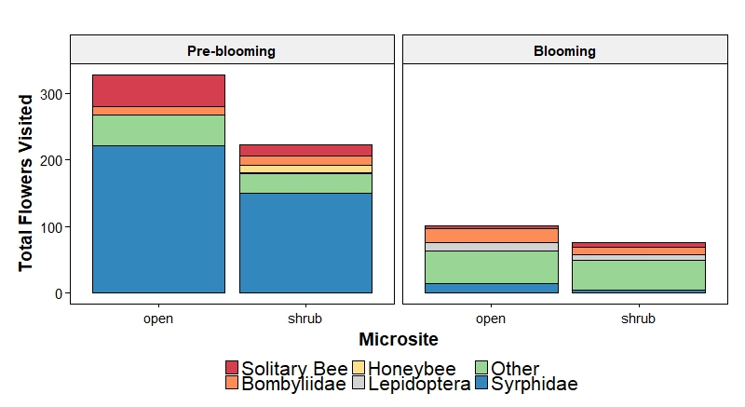

Figure 1: The contribution of each recognizable taxonomic group (RTU) to the total number of flowers visited (weighted by video length) for each treatment.

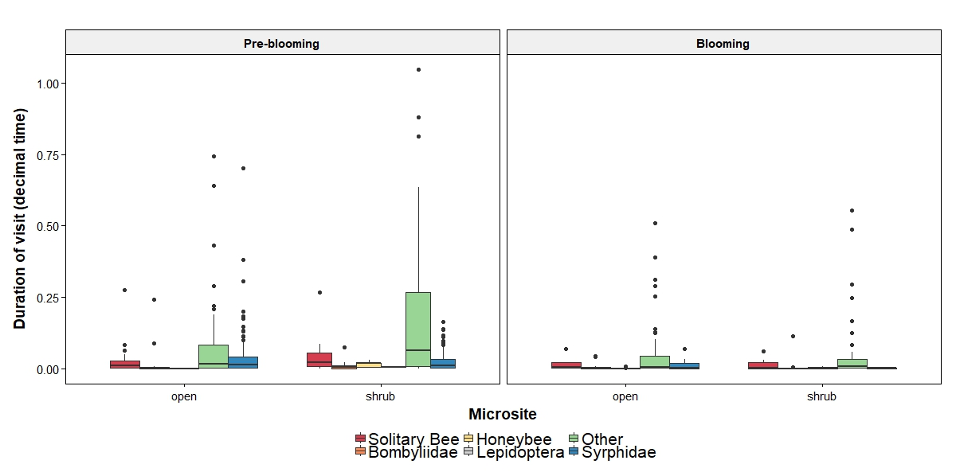

Figure 2: RTU specific responses in visit duration before and during blooming at each microsite.

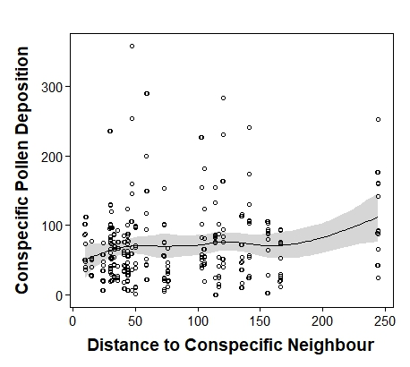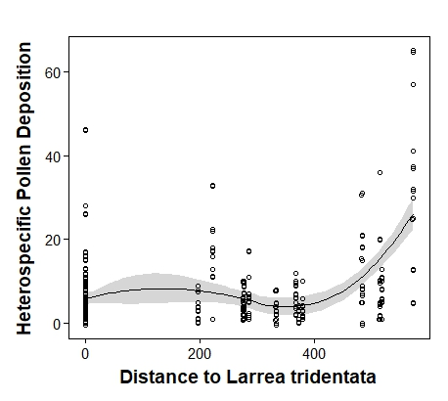

Figure 3: Heterospecific pollen deposition on the stigmas of Malacothrix glabrata increased with distance (in cm). There was a marginally significant effect of distance to nearest M. glabrata on conspecific pollen deposition. Mean distance to shrub was 1.83 m, mean distance to nearest conspecific neighbour was 0.79 m and mean number of flowers of M. glabrata was 7.

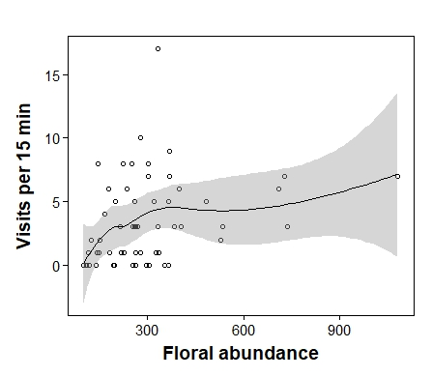

Figure 4: Pollinator visitation rates increased with the number of *Larrea tridentata* flowers.

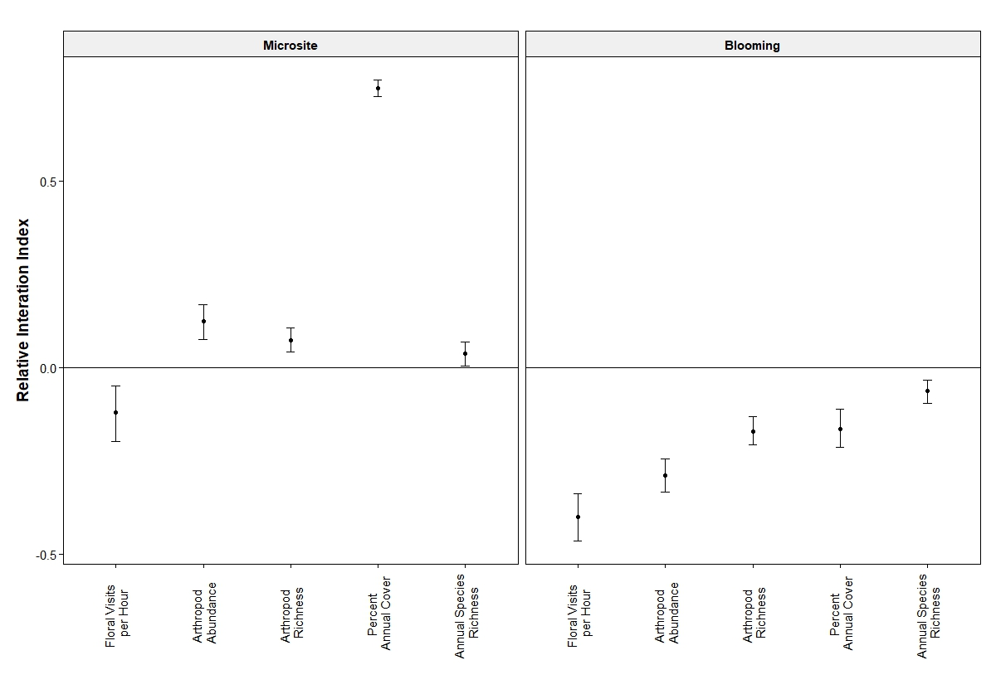

Figure 5: Relative Interaction Index (RII) values for five community interaction metrics among two treatments: Microsite and Blooming. Values shown are means ± 95% bootstrapped confidence intervals. Values greater than zero indicate positive effects, while values that are significantly lower than zero indicate negative effects. Values that are not significantly different from zero are neutral.

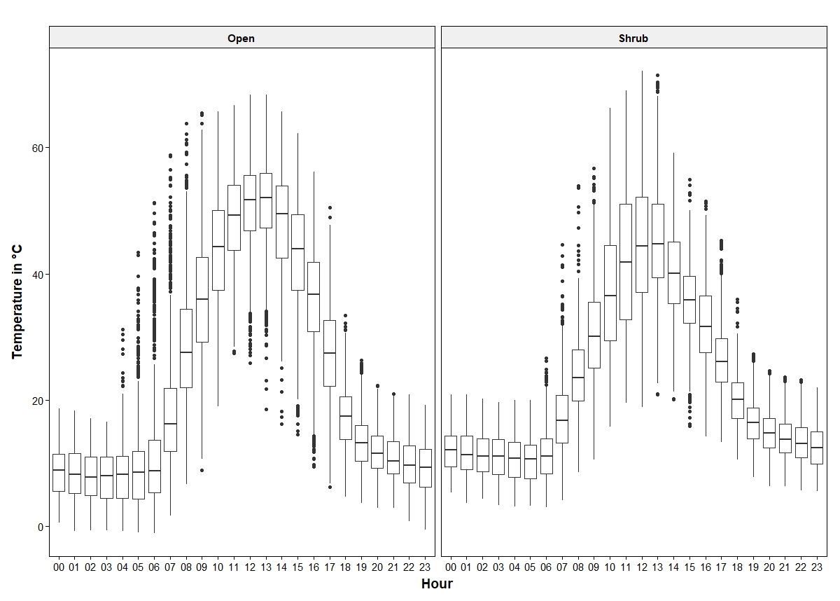

Figure 6: Hobo Pendant Data Loggers recorded microenvironmental conditions for the extent of the study period. Values shown are mean hourly temperatures for all microsites (eight open and eight shrub) between March 17th and May 14th.

Tables

Table 1: Results from negative binomial generalized linear mixed models (lme4, glmer.nb) testing for differences in the frequency of pollinator floral visits and foraging bouts in response to microsite (shrub and open) and blooming stage (pre-blooming and full bloom). Conspecific floral density was included as a predictor and the log-transformed length of video was used as an offset as a measure of exposure. The repID (shrub ID + microsite) was used a random effect in both models to account for the repeated measures study design. Significance was denoted at α = 0.05 and shown in bold. Non-significant interactions were excluded from all models.

|  |  |  |  |  |  |  |
| --- | --- | --- | --- | --- | --- | --- |
|  | Total flower visits | | | Foraging bouts | | |
|  | **Coeff** | **χ2** | **p** | **Coeff** | **χ2** | **p** |
| Microsite (shrub) | -0.3493 | 4.4979 | **0.03396** | -0.3258 | 5.1183 | **0.0237** |
| Blooming (bloom) | -1.2473 | 61.52 | **<0.0001** | -1.2513 | 76.883 | **<0.0001** |
| Flowers.pot | 0.0694 | 6.9013 | **0.0086** | 0.0474 | 4.1109 | **0.0426** |
| Microsite * Blooming | NA | NA | NA | NA | NA | NA |

Table 2: Results from GLMM (glmmTMB) testing for the influence of heterospecific annual floral density and shrub blooming density on the frequency of pollinator floral visits and foraging bouts. The log-transformed length of video was used as an offset as a measure of exposure. The repID (shrub ID + microsite) was used a random effect in both models to account for the repeated measures study design. Significance was denoted at α = 0.05 and shown in bold.

|  |  |  |  |  |  |  |  |  |  |
| --- | --- | --- | --- | --- | --- | --- | --- | --- | --- |
|  | Total flower visits | | | |  | Foraging bouts | | | |
|  | **Coeff** | **SE** | **z** | **p** |  | **Coeff** | **SE** | **z** | **p** |
| Microsite (shrub) | -0.3660 | 0.16944 | -2.160 | **0.03077** |  | -0.33019 | 0.14706 | -2.25 | **0.02475** |
| Blooming (bloom) | -1.2396 | 0.16353 | -7.581 | **<0.0001** |  | -1.24571 | 0.14513 | -8.58 | **<0.0001** |
| Flowers.pot | 0.08084 | 0.02711 | 2.981 | **0.00287** |  | 0.05943 | 0.02374 | 2.503 | **0.01230** |
| Heterospecific  annual bloom density | 0.04013 | 0.02342 | 1.713 | 0.08664 |  | 0.04086 | 0.01984 | 2.059 | **0.03950** |
| Microsite (shrub) | -0.3289 | 0.16998 | -1.935 | **0.05301** |  | -0.31539 | 0.14829 | -2.13 | **0.033435** |
| Blooming (bloom) | -1.1662 | 0.18601 | -6.269 | **<0.0001** |  | -1.20875 | 0.16707 | -7.24 | **<0.0001** |
| Flowers.pot | 0.07598 | 0.02703 | 2.811 | **0.00494** |  | 0.05296 | 0.02376 | 2.229 | **0.025799** |
| Heterospecific  blooming shrub density | -0.0494 | 0.04093 | -1.207 | 0.22744 |  | 0.03124 | 0.03744 | -0.84 | 0.403997 |

|  |  |  |  |  |  |  |  |
| --- | --- | --- | --- | --- | --- | --- | --- |
|  | Total flower visits | | |  | Foraging bouts | | |
|  | **Coeff** | **χ2** | **p** |  | **Coeff** | **χ2** | **p** |
| Microsite (shrub) | -0.337480 | 4.1903 | **0.040655** |  | -0.311383 | 4.6322 | **0.03137** |
| Blooming (bloom) | -1.729417 | 15.4730 | **< 0.0001** |  | -1.683054 | 12.2157 | **0.0004739** |
| RTU | NA | 197.0575 | **<0.0001** |  | NA | 217.5031 | **<0.00001** |
| Flowers.pot | 0.064325 | 7.8743 | **0.005014** |  | 0.042763 | 4.0741 | 0.4354 |
| RTU*blooming | NA | 70.0222 | **<0.0001** |  | NA | 70.35 | **<0.0001** |

Table 3: Results from quasi-Poisson GLMM (MASS, glmmPQL) testing for RTU specific responses to blooming stage. The log-transformed length of video was used as an offset as a measure of exposure. The repID (shrub ID + microsite) was used a random effect to account for the repeated measures study design. Posthoc comparisons (lsmeans) contrasting RTU specific responses between pre-blooming and blooming were done on significant interactions. Significance was denoted at α = 0.05 and shown in bold.

|  |  |  |  |  |  |  |  |  |
| --- | --- | --- | --- | --- | --- | --- | --- | --- |
| Contrast: Pre blooming vs blooming | | | | |  | | | |
| RTU | **Estimate** | **SE** | **t.ratio** | **p** | **estimate** | **SE** | **t.ratio** | **p** |
| Solitary bee | 1.7294 | .4419 | 3.914 | **0.0001** | 1.6831 | .4840 | 3.478 | **0.0005** |
| Bombyliidae | 0.04603 | .3886 | 0.118 | 0.9057 | 0.3956 | .3.5568 | 1.112 | 0.2662 |
| Honeybee | 24.9969 | 77838 | 0.000 | 0.9997 | 24.3349 | 65302.3 | 0.000 | 0.9997 |
| Lepidoptera | -2.4017 | 1.28900 | -1.862 | 0.0629 | -2.0771 | 1.0625 | -1.955 | 0.0508 |
| Other | -0.0197 | .2403 | -0.082 | 0.9347 | 0.1341 | .2065 | 0.64 | 0.5163 |
| Syrphid | 3.0563 | .3347 | 8.813 | **<0.0001** | 3.1228 | .3404 | 9.173 | **<0.0001** |

Table 4: Results from Gamma GLMM (lme4, glmer.nb) testing for differences visit duration and the proportion of flowers visited per visit in response to microsite (shrub and open) and blooming stage (pre-blooming and full bloom). The repID (shrub ID + microsite) was used a random effect in both models to account for the repeated measures study design. Significance was denoted at α = 0.05 and shown in bold. Non-significant interactions were excluded from all models.

|  |  |  |  |  |  |  |  |
| --- | --- | --- | --- | --- | --- | --- | --- |
|  | Visit duration | | | | Proportion of flowers visited | | |
|  | **Coef** | | **χ2 value** | **p – value** | **Coef** | **χ2 value** | **p – value** |
| Microsite | -0.047260 | 0.0464 | | 0.8295 | -0.03538 | 1.0051 | 0.46515 |
| Blooming | -0.777931 | | 23.1788 | **<0.0001** | 0.0805 | 0.5335 | 0.31609 |
| Microsite * Blooming | NA | | NA | NA | -0.20443 | 7.0691 | **0.00784** |

Table 5: Results from quasi-Poisson GLMM (MASS, glmmPQL) testing for the influence of *L. tridentata*, and two metrics of conspecific density on conspecific and heterospecific pollen deposition. Sample ID nested in flower ID nested in plant was used as a random effect to account for multiples samples coming from individual plants. Significance was denoted at α = 0.05 and shown in bold.

|  |  |  |  |  |  |  |
| --- | --- | --- | --- | --- | --- | --- |
|  | Conspecific Pollen Deposition | | | Heterospecific Pollen Deposition | | |
|  | **Coef** | **χ2 value** | **p – value** | **Coef** | **χ2 value** | **p – value** |
| Distance to *L. tridentata* | 0.0002 | 0.8803 | 0.3533 | 0.00130 | 23.7883 | **<0.0001** |
| Distance to *M. glabrata* | 0.0015 | 3.8146 | 0.0541 | -0.0014 | 2.1656 | 0.1411 |
| *M. glabrata* floral number | 0.0089 | 2.0027 | 0.1620 | -0.0122 | 2.3713 | 0.1236 |

Table 6: Results from negative binomial generalized linear mixed models (lme4, glmer.nb) testing for differences in arthropod abundance in response to microsite (shrub and open) and blooming stage (pre-blooming and full bloom). Melyridae beetles comprised 1217/3384 individuals, models were fit with them excluded, included and individually. The repID (shrub ID + microsite) was used a random effect in both models to account for the repeated measures study design. Significance was denoted at α = 0.05 and shown in bold. And Poisson models

|  |  |  |  |  |  |  |  |  |  |
| --- | --- | --- | --- | --- | --- | --- | --- | --- | --- |
|  | Insect abundance (Melyridae: excluded) | | | Arthropod Species Richness | | | Bee abundance | | |
|  | **Coef** | **χ**2 | p | **Coef** | **χ**2 | p | **Coef** | **χ**2 | p |
| Microsite  (shrub) | 0.40610 | 15.4926 | **<0.0001** | 0.14541 | 6.6289 | **0.01** | 0.05766 | 0.0792 | 0.778323 |
| Blooming  (in bloom) | -0.39624 | 13.5868 | **0.000228** | -0.25442 | 25.6295 | **<0.0001** | -0.0787 | 0.2104 | 0.646419 |
| Microsite * Blooming | -0.27673 | 3.4553 | 0.063049 | NA | NA | NA | NA | NA | NA |

|  |  |  |  |  |  |  |  |  |  |
| --- | --- | --- | --- | --- | --- | --- | --- | --- | --- |
|  | Percent cover | | | Annual Richness | | | Annual Bloom Density | | |
|  | **Coef** | **χ**2 | p | **Coef** | **χ**2 | p | **Coef** | **χ**2 | p |
| Microsite | 1.7599 | 165. | **<0.0001** | 0.0719 | 0.7071 | 0.40 | -0.28 | 0.601 | 0.438 |
| Blooming | -0.793 | 34.180 | **<0.0001** | 0.1407 | 2.7010 | 0.10 | -1.36 | 13.3646 | **0.0003** |
| Microsite * blooming | 0.794 | 22.806 | **<0.0001** | NA | NA | NA | NA | NA | NA |

Table 7: Results from negative binomial generalized linear mixed models (lme4, glmer.nb) testing for differences in annual percent cover, annual species richness and annual blooming density in response to microsite (shrub and open) and blooming stage (pre-blooming and full bloom). The repID (shrub ID + microsite) was used a random effect in both models to account for the repeated measures study design. Significance was denoted at α = 0.05 and shown in bold. Non-significant interactions were excluded from all models.

Appendix:

Table A1: A list of all RTU for Chapter 2. All RTU all exclusive and no individuals were double counted. 121 taxonomic groups were counted.

|  |  |  |  |  |  |  |
| --- | --- | --- | --- | --- | --- | --- |
| Order | Superfamily | Family | Subfamily | Genus | Species | Total Collected |
| Aranae |  |  |  |  |  | 14 |
| Coleoptera |  | Buprestidae |  |  |  | 67 |
|  |  | Chrysomelidae |  |  |  | 7 |
|  |  | Coccinellidae |  |  |  | 6 |
|  |  | Curculionidae |  |  |  | 15 |
|  |  | Meloidae | Meloinae | Cysteodemus |  | 2 |
|  |  | Meloidae | Meloinae | Eupompha | Eupompha elegans | 3 |
|  |  | Meloidae | Meloinae | Lytta | Lytta auriculata | 3 |
|  |  | Meloidae | Meloinae | Lytta |  | 1 |
|  |  | Melyridae |  |  |  | 1243 |
| Diptera |  |  |  |  | Acalyptrate - Tiny | 1 |
|  |  | Anthomyiidae |  |  |  | 4 |
|  |  | Asilidae |  |  |  | 76 |
|  |  | Bombyliidae | Ussinae |  |  | 8 |
|  |  | Bombyliidae | Anthracinae | Aphoebantus |  | 2 |
|  |  | Bombyliidae |  |  |  | 23 |
|  |  | Calliphoridae |  |  |  | 1 |
|  |  | Canacidae |  |  |  | 1 |
|  |  | Cecidomyiidae |  |  |  | 55 |
|  |  | Chamaemyiidae |  |  |  | 1 |
|  |  | Chloropidae |  |  |  | 21 |
|  |  | Chyromyidae |  |  |  | 1 |
|  |  | Drosophilidae |  |  |  | 1 |
|  |  | Ephydridae |  |  |  | 12 |
|  |  | Heleomyzidae |  |  |  | 73 |
|  |  | Milichiidae |  |  |  | 10 |
|  |  | Muscidae |  |  |  | 3 |
|  |  | Mythicomyiidae |  |  |  | 258 |
|  |  | Phoridae |  |  |  | 17 |
|  |  | Pipunculidae |  |  |  | 8 |
|  |  | Richardiidae |  | Omomyia |  | 3 |
|  |  | Sarcophagidae |  |  |  | 22 |
|  |  | Sciaridae |  |  |  | 6 |
|  |  | Syrphidae | Syrphinae | Eupeodes | Eupeodes volucris | 19 |
|  |  | Syrphidae | Syrphinae | Toxomerus | Toxomerus marginatus | 1 |
|  |  | Tachinidae |  |  |  | 17 |
|  |  | Tephritidae |  |  |  | 7 |
|  |  | Therevidae |  |  |  | 4 |
| Hemiptera |  | Anthocoridae |  |  |  | 3 |
|  |  | Aphididae |  |  |  | 10 |
|  |  | Berytidae | Gampsocorinae |  | Pronotacantha annulata | 17 |
|  |  | Berytidae |  |  |  | 4 |
|  |  | Cercopidae |  |  |  | 6 |
|  |  | Cicadellidae |  |  |  | 351 |
|  |  | Delphacidae |  |  |  | 2 |
|  |  | Geocoridae |  |  |  | 14 |
|  |  | Membracidae |  |  |  | 1 |
|  |  | Miridae |  |  |  | 96 |
|  |  | Nymph |  |  |  | 176 |
|  |  | Pentamoidae |  |  |  | 6 |
|  |  | Reduviidae | Harpactorinae |  |  | 10 |
|  |  | Rhopadilae |  |  |  | 7 |
|  |  | Tingidae |  |  |  | 2 |
|  | Lygaeoidea |  |  |  |  | 21 |
|  | Psylloidea |  |  |  |  | 2 |
| Hymenoptera | Apoidea (Anthophila) | Andrenidae | Andreninae |  | Ancylandrena larreae | 1 |
|  |  |  | Andreninae | Andrena |  | 2 |
|  |  |  | Panurginae | Calliopsis |  | 1 |
|  |  |  | Andreninae |  | Megandrena encelia | 14 |
|  |  | Apidae | Apinae |  | Apis mellifera | 4 |
|  |  |  | Apinae | Diadasia |  | 12 |
|  |  |  | Apinae | Eucera |  | 2 |
|  |  |  | Apinae | Mellisodes |  | 4 |
|  |  | Andrenidae | Panurginae | Perdita |  | 1 |
|  |  | Colletidae | Colletinae | Colletes |  | 2 |
|  |  | Halictidae | Halictinae | Halictus |  | 7 |
|  |  |  | Halictinae | Lasioglossum |  | 72 |
|  |  | Megachilidae | Megachilinae | Anthidium |  | 4 |
|  |  |  | Megachilinae | Ashmeadiella |  | 4 |
|  |  |  | Megachilinae | Atoposmia |  | 1 |
|  |  |  | Megachilinae | Hoplitis |  | 1 |
|  |  |  | Megachilinae | Megachile |  | 1 |
|  |  |  | Megachilinae | Osmia |  | 9 |
|  |  | Melittidae | Dasypodainae | Hesperapis |  | 2 |
|  | Apoidea (wasps) | Crabronidae |  |  |  | 39 |
|  |  | Crabronidae | Pemphredoninae |  |  | 27 |
|  |  | Crabronidae | Astatinae | Dryudella |  | 1 |
|  |  | Crabronidae | Crabroninae | Miscophus |  | 25 |
|  |  | Sphecidae | Ammophilinae | Ammophila |  | 4 |
|  |  | Sphecidae |  |  |  | 1 |
|  | Chrysidoidea | Chrysididae |  |  |  | 12 |
|  |  | Dryinidae |  |  |  | 1 |
|  | Formicidoidea | Formicidae |  |  |  | 71 |
|  | [Pompiloidea](https://bugguide.net/node/view/787796) | Mutillidae |  |  |  | 11 |
|  |  | Myrmosidae |  |  |  | 1 |
|  |  | Pompilidae |  |  |  | 13 |
|  | [Vespoidea](https://bugguide.net/node/view/117329) | Vespidae | Eumeninae |  |  | 1 |
| Parasitica |  | Ceraphronidae |  |  |  | 6 |
|  |  | Megaspilidae |  |  |  | 1 |
|  | Ceraphronoidea |  |  |  | wingless | 1 |
|  |  | Platygastridae |  |  |  | 7 |
|  | Chalcidoidea | Chalcididae |  |  |  | 3 |
|  |  | Encrytidae |  |  |  | 23 |
|  |  | Eucharitidae |  |  |  | 2 |
|  |  | Eulophidae |  |  |  | 16 |
|  |  | Eupelmidae |  |  |  | 13 |
|  |  | Eurytomidae |  |  |  | 4 |
|  |  | Mymaridae |  |  |  | 1 |
|  |  | Perilampidae |  |  |  | 1 |
|  |  | Pteromalidae |  |  |  | 25 |
|  |  | Torymidae |  |  |  | 10 |
|  |  | Trichogrammatidae |  |  |  | 4 |
|  |  | Signiphoridae |  |  |  | 3 |
|  | [Cynipoidea](https://bugguide.net/node/view/14738) | Figitidae |  |  |  | 1 |
|  | Ichnuemoidea | Braconidae |  |  |  | 1 |
|  |  | Ichneumonidae | Tersilochinae |  |  | 1 |
|  |  | Ichneumonidae |  |  |  | 1 |
| Lepidoptera | Adeloidea |  |  |  |  | 1 |
| Lepidoptera |  | Nymphalidae |  |  |  | 2 |
| Lepidoptera |  | Papilionidae |  |  |  | 1 |
| Lepidoptera |  |  |  |  |  | 1 |
| Microcorphyia |  |  |  |  |  | 1 |
| Neuroptera |  | Chrysopidae |  |  |  | 1 |
| Orthoptera |  |  |  |  |  | 19 |
| Solifugae |  |  |  |  |  | 3 |
| Thysanoptera |  |  |  |  |  | 137 |
| Trichoptera |  |  |  |  |  | 1 |

Appendix B

Model selection from results of Table 1 and full model of Table 3.

Table B1: Likelihood ratio test comparison of random intercept model, additive and interaction GLMM negative binomial models for where total flower visits are the response variable. Null model is flowers.pot with the random intercept, additive is flower.pot + blooming + microsite and interaction in flowers.pot + blooming * microsite.

|  |  |  |  |  |  |
| --- | --- | --- | --- | --- | --- |
| Model | DF | AIC | BIC | Chisq | P > Chisq |
| Null | 4 | 1164.8 | 1178.6 |  |  |
| Additive | 6 | 1111.6 | 1132.3 | 57.1788 | <0.00001 |
| Interaction term | 7 | 1113.6 | 1137.8 | 0.0322 | 0.8576 |

Table B2: Likelihood ratio test comparison of random intercept model, additive and interaction GLMM negative binomial models for where total plant visits are the response variable. Null model is flowers.pot with the random intercept, additive is flower.pot + blooming + microsite and interaction in flowers.pot + blooming * microsite.

|  |  |  |  |  |  |
| --- | --- | --- | --- | --- | --- |
| Model | DF | AIC | BIC | Chisq | P > Chisq |
| Null | 4 | 1066.0 | 1079.8 |  |  |
| Additive | 6 | 1000.7 | 1021.5 | 69.2940 | <0.00001 |
| Interaction term | 7 | 1002.7 | 1026.9 | 0.0072 | 0.9326 |

Table B3: Full models. Quasipoisson GLMM (glmmPQL, MASS) with three0way interaction term for RTU*blooming*microsite. This output from Wald’s Type 3 test. Total flower visits and foraging bouts as response. Rep ID as random effect.

|  |  |  |  |  |  |  |
| --- | --- | --- | --- | --- | --- | --- |
|  | Flower visits | | | Foraging bouts | | |
|  | Chisq | Df | P |  |  |  |
| Flowering | 16.3114 | 1 | **<0.0001** | 11.2812 | 1 | **0.0007829** |
| Rtu | 121.6832 | 5 | **<0.0001** | 131.340 | 5 | **<0.0001** |
| Treatment | 6.7008 | 1 | **0.009637** | 3.6569 | 1 | 0.0558390 |
| Flowers.pot | 9.4194 | 1 | **0.002147** | 4.5640 | 1 | **0.0326507** |
| Flowering:rtu | 56.9111 | 5 | **<0.0001** | 53.0033 | 5 | **<0.0001** |
| Flowering:treatment | 3.6394 | 1 | 0.056426 | 2.3436 | 1 | 0.1258002 |
| Rtu:treatment | 5.4996 | 5 | 0.357984 | 3.8289 | 5 | 0.5743031 |
| Flowering:rtu:treatment | 7.5190 | 5 | 0.184812 | 4.1995 | 5 | 0.5210663 |

Appendix C

Table C1: GLMM for arthropod abundance – Melyridae included and Melyridae only.

|  |  |  |  |  |  |  |
| --- | --- | --- | --- | --- | --- | --- |
|  | Insect abundance (Melyridae: included) | | | Melyridae: abundance only | | |
|  | **Coef** | **χ2** | **p** | **Coef** | **χ2** | **p** |
| Microsite (shrub) | -0.09872 | 1.808 | 0.1787 | -1.1920 | 38.0394 | **0<0.0001** |
| Blooming (in bloom) | -0.39280 | 33.553 | **<0.00001** | -0.2989 | 3.3485 | 0.067267 |
| Microsite * Blooming | NA | NA | NA | 0.6521 | 7.1290 | **0.007585** |

Appendix D: Post-hoc contrasts

Table D1: Results from post-hoc test (lsmeans, Tukey’s) for the Gamma generalized linear mixed model on significant interaction for proportion of flowers visited. Significance was denoted at α = 0.05 and shown in bold. Proportion of flowers visited

|  |  |  |  |  |
| --- | --- | --- | --- | --- |
|  | Proportion of flowers visited | | | |
| Contrast | **Estimate** | **SE** | **t.ratio** | **p** |
| pre,open - post,open | 0.03537548 | 0.04843350 | 0.730 | 0.8849 |
| pre,open - pre,shrub | -0.08050042 | 0.08029773 | -1.003 | 0.7479 |
| pre,open - post,shrub | 0.15930471 | 0.08775466 | 1.815 | 0.2660 |
| post,open - pre,shrub | -0.11587589 | 0.08384195 | -1.382 | 0.5106 |
| post,open - post,shrub | 0.12392924 | 0.09113159 | 1.360 | 0.5247 |
| pre,shrub - post,shrub | 0.23980513 | 0.05952906 | 4.028 | **0.0003** |

Table D2: Post-hoc contrasts on significant interaction for abundance (Melyridae excluded) for microsite by blooming. Significant is at alpha < 0.05 and indicated in bold.

|  |  |  |  |  |
| --- | --- | --- | --- | --- |
| Contrast | Estimate | SE | Z | p |
| pre,open - post,open | 0.3962370 | 0.1074971 | 3.686 | **0.0013** |
| pre,open - post,open | -0.4060998 | 0.1031742 | -3.936 | **0.0005** |
| pre,open - post,shrub | 0.2668669 | 0.1060437 | 2.517 | 0.0574 |
| post,open - pre,shrub | -0.8023367 | 0.1044866 | -7.679 | **<.0001** |
| post,open - post,shrub | -0.1293701 | 0.1073211 | -1.205 | 0.6234 |
| pre,shrub - post,shrub | 0.6729667 | 0.1029908 | 6.534 | **<.0001** |

Table D3: Post-hoc contrasts interaction for abundance (Melyridae only) for microsite by

blooming. Significant is at alpha < 0.05 and indicated in bold.

|  |  |  |  |  |
| --- | --- | --- | --- | --- |
| Contrast | Estimate | SE | Z | p |
| pre,open - post,open | 0.2989089 | 0.1633482 | 1.830 | 0.2592 |
| pre,open - post,open | 1.1920062 | 0.1932688 | 6.168 | **<.0001** |
| pre,open - post,shrub | 0.8388073 | 0.1826136 | 4.593 | **<.0001** |
| post,open - pre,shrub | 0.8930973 | 0.1906721 | 4.684 | **<.0001** |
| post,open - post,shrub | 0.5398984 | 0.1799142 | 3.001 | **0.0143** |
| pre,shrub - post,shrub | -0.3531989 | 0.1815186 | -1.946 | 0.2090 |